

VILNIUS UNIVERSITY
SIAULIAI ACADEMY
BACHELOR PROGRAMME SOFTWARE ENGINEERING

ELECTRONIC BOOK SHOP

E-service Design Principles and Infrastructure Solutions. Practical Work №4-5

Student :
Lecturer: Prof. Dr. Dale Dzemydiene

Siauliai, 2023

Electronic book shop is a digital version of a book shop. It is a software system with the possibility to buy paper-based books, digital books or take a paper-based books for a short period of time.

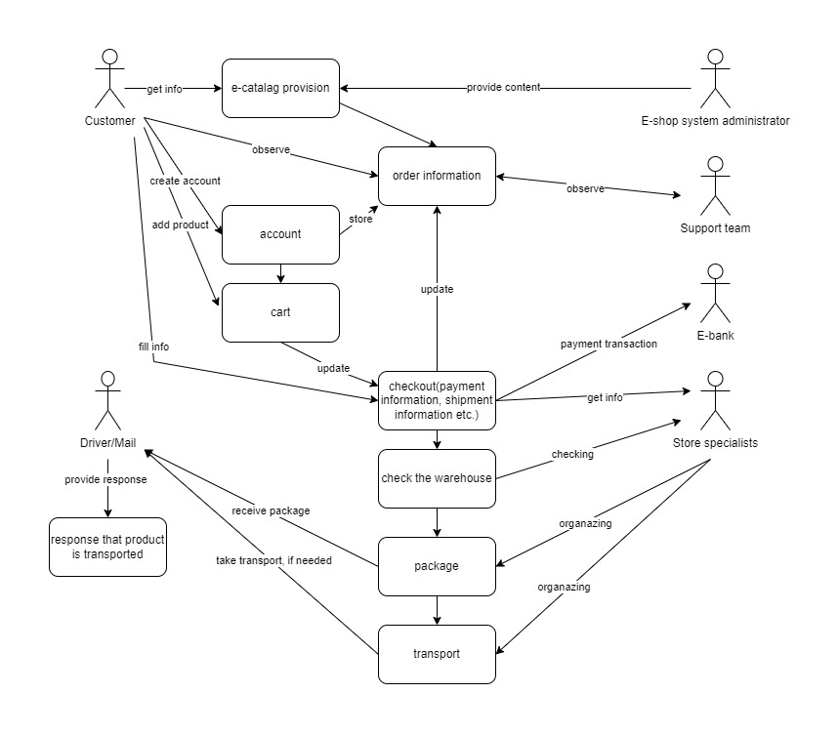
Use-case model:

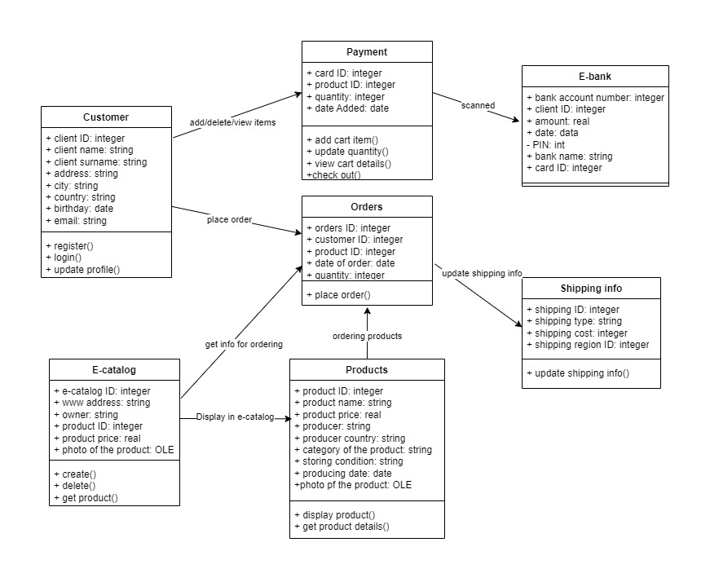
Class diagram:

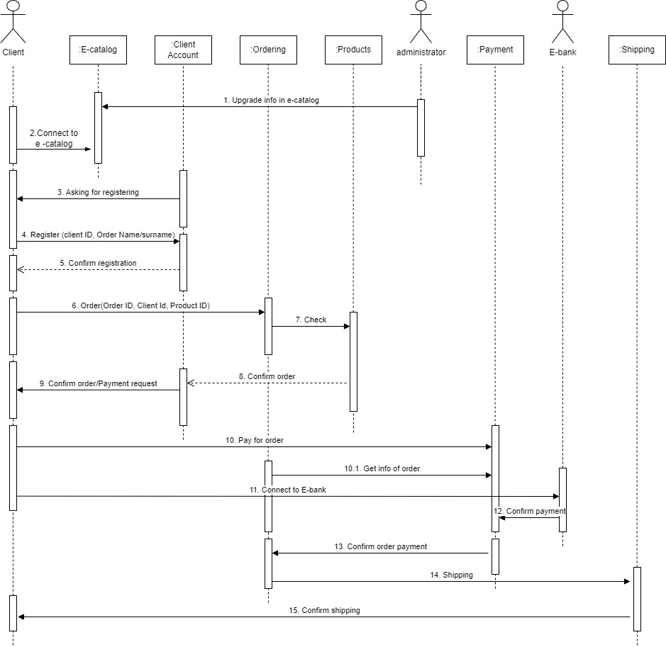
Sequence:

